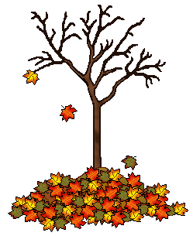
Pendle Primary School
Autumn Term 2025
Years 3 and 4







From Miss Ridgway Mrs Schofield Mr Taylor Mrs Wardle Mr Morris

Homework
Please look at the new school website and your child’s class page – Ash Class, Beech Class and Willow Class for details of this half term’s homework.
We look forward to seeing all of your wonderful work that you have created at home with your families.
Times Tables
Please help your child with the following times tables and ensure that they complete their weekly TT sessions. Please record the daily session in your new homework diary –
Year 3 – 2,3,4,5,10
Year 4 – 2,3,4,5,6,7,8,9,10,11,12

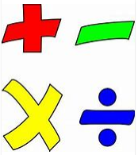

You might also like to try
https://www.topmarks.co.uk/maths-games/daily10

https://www.bbc.co.uk/sport/supermovers/42612499

Reading

Reading books should be taken home each night so that your child can continue to practise this most important skill. It would be most helpful if you could add your comments to the new homework diary and ensure that the reading packet is returned to school each day.
Reading for 10-15 minutes each night will have a real impact on your child’s progress in school and we hope you both enjoy the experience.
PE
Please ensure that your child has a full outdoor and indoor PE kit in school. This continues to be vital at this time as most of our physical education sessions will take place in the fresh air.
It would be extremely helpful if your child’s PE kit was named, including pumps/trainers, and remained in school until half-term washing. Roefield does not take place until Autumn 2. Swimming news to follow.
This term, in the following subjects, we will be focusing on:
Science: Forces and Magnets
Geography: Why do people live near volcanoes?
History: How have children’s lives changed?
RE: Hindu Dharma
Music: Ballads Y3 WOPPS Y4
Art: Sculpture – Giacometti and Picasso
DT – Shell Structures
PE: Orienteering/Net and Wall
In our Maths lessons we will be following the Lancashire Mastery Scheme
In our Literacy lessons we will be studying the topics set by the Lancashire Literacy Team – Folk Tales and Biographies

