
Apple Class and Cherry Class Topic Letter
Autumn 1
Monday 1st September
We are delighted to share our very first topic letter with you! A topic letter will be emailed to you each half term to outline the term’s theme/topic, and give you an insight into what we will be up to in class. A weekly overview of learning will also be put up each week in the yellow owl board on your way into school, as well as on the website.
This first topic letter will be slightly lengthier to a typical topic letter but provides lots of important information about your child’s first term. We really appreciate your support so far.
Our first topic this year is… “Who Am I and Where Do I Live?”
Lots of our time in September is spent settling the children into their new school, and supporting them through the transition process. We will also be talking about ourselves and what makes us special, as well as our families! We will explore the local area of Clitheroe, as well as share the Traditional Tale, Goldilocks and the Three Bears!
Within Maths, we will start to explore numbers 1-3 and we will begin our Phonics journey by introducing our Phonics friend, Fred and learning our first letters, s a t p i n.
As families, you are an extremely important part of your child’s learning journey at Pendle! For this topic, and to support discussions about family, we would love for you to send us a family photo. This will be shared in class, and displayed for the children to see at school. Please email these to:
Apple– appleclass@pendle.lancs.sch.uk
Cherry – cherry@pendle.lancs.sch.uk
(These emails are not monitored daily, so please ensure urgent queries are communicated on drop off / pick up or via the school office).
As part of our discussions about family, we will be talking about our favourite memories. We would love it if you could email in a photo to support these discussions. This could be a holiday picture, a special day out, or another memorable moment your child would like to share with us. Please send your photos by the 12th of September.
Thank you for helping us make our learning personal and meaningful for the children.

Our class pages will be regularly updated to provide you with a sneak peek into all the fun we are having! It is recommended to look at these with your child to avoid the inevitable “I forgot” when they are asked what they did that day.
Please ensure that your child’s PE bag, book bag and named wellies come to school with them by the end of their first full time week (by Friday 12th September). Remember to pack at least 2 pairs of spares in here, even if your child is not prone to ‘accidents’. Please let us know if you require support to provide these as we often have spares.
Please also ensure you have been onto Cool Milk to register your child for free school milk. It is useful to have a reminder set a week before your child’s 5th birthday to re-register dependent upon whether your child would like to continue having milk.
All other information can be found in the Induction Booklet, and of course by asking any of the Early Years team.
You will be invited into school throughout the year for a variety of events, such as Stay and Play sessions and curriculum meetings. We aim to schedule these on different days and at different times to give everyone the best chance to attend. Wherever possible, we will provide plenty of notice. Dates for the Autumn term will be shared separately once the children have settled.
As a very special first event, we would like to invite one parent/carer to join their child for lunch at school.
- Cherry Class – Wednesday 1st October at 11:30am
- Apple Class – Thursday 2nd October at 11:30am
We look forward to welcoming you into school and sharing these moments with you.
Thank you for taking the time to read what is a lengthier topic letter – however, we hope this eases the transition for both you and your child.
We are very excited for the year ahead!
If you have any concerns or questions, please do not hesitate to ask!
Thank you for your support so far!
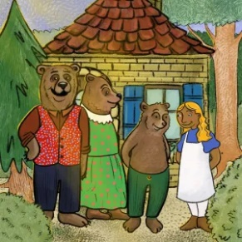
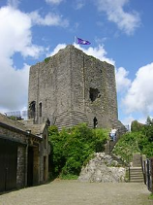

Miss Lancaster, Miss Pritchard and Miss DeRosa and the Early Years Team.

