
Cherry Class Topic Letter
Autumn 1
Monday 1st September
Welcome to Cherry Class! The children have enjoyed sharing their summer holiday memories with us, and they seem eager and ready for a busy yet exciting term ahead.
Over the year a balance of topics will be taught that are planned to cover the National Curriculum requirements for children in Year One.

Our first topic this year is… “Who Am I and Where Do I Live?”
Learning will continue to occur through structured and practical activities, which will gradually develop to include more recording of their work. English, phonics and maths will be taught every day.

Science - We will be learning about our body parts, identifying and naming them.
RE - We will be exploring Christian Stories about Creation, as well as considering why our planet / world is a special place to many.
The following subjects continue over Autumn 1 and Autumn 2:
History - We will learn about what history is, placing significant life events on a timeline and talking about the past and present.
Geography - We will explore our school grounds, creating and exploring maps before then making our own suggestions for how areas could be improved.
Art - We are going to explore and share our opinions on the work of LS Lowry. We will then investigate techniques and effects used by the artist and apply these within our own artwork.
DT - We will investigate different slider and lever mechanisms, practise creating our own and then apply those skills to create our own greetings cards.

To support discussions about family, we would love for you to send us a family photo. This will be shared in class, and displayed for the children to see at school. Please email these to:
Cherry – cherry@pendle.lancs.sch.uk
(These emails are not monitored daily, so please ensure urgent queries are communicated on drop off / pick up or via the school office).
Keep looking at our Cherry Class class page as it is updated regularly with additional information about what we are learning along with photographs and videos.

Just as a reminder, the children should keep their PE bags in school in case of timetable changes. We are extremely excited to start Forest Friday. Please ensure that your child has named wellies in school.

Depending on whether your child wants to continue receiving milk, you might need to re-register your child for milk on Cool Milk as many Year 1 children in Cherry Class turned 5 over the summer break.
We will continue to invite you into school over the year for various events, such as Stay and Play sessions and curriculum meetings for example. We do endeavour to ensure these take place on a range of days and times across the year to ensure you are able to attend as many as possible. We always aim to give as much notice as we can.
Thank you for taking the time to read what is a lengthier topic letter. We are very excited for the year ahead!
If you have any concerns or questions, please do not hesitate to ask!
Thank you for your support so far!
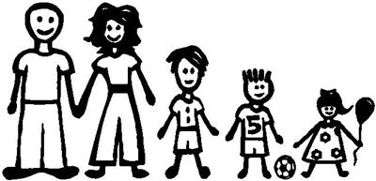
Miss Lancaster and Miss DeRosa

