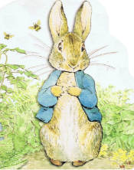
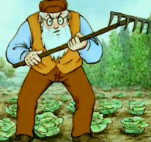

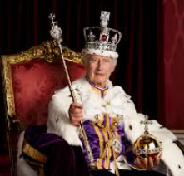
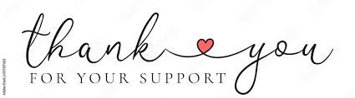
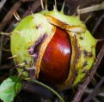
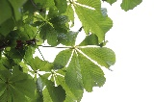
Music – Theme- Space We will be listening to music and responding creatively, considering how dynamics can be represented.

PRSHE – Being My Best – ‘What helps us stay healthy?’

Phonics [Y1] – We will be recapping and consolidating the phonemes: oa [float],
ow [snow], oe [toe], o-e [stone] and o [both]. New learning: ol [cold] and oul [shoulder].

English – We will be creating a character profile about Mr McGregor and Peter Rabbit. We will use expanded noun phrases within our written work. We will be

Spelling [Y2] –We will be revising words with the sound –le, -el and –al at the end of words e.g. camel, decimal and castle.

History – We will explore coronations by acting out the ceremony.
RE – We will be identifying some features of a Christian church.
Art – This half term, we will be completing an art project with Mrs Govender.

PE – Cricket skills
Under arm throwing skills.
Science – We will be recognising how scientists answer questions.
Maths –
Year 1 – Time - We will be sequencing events, telling the time to the hour and the half hour.

Year 2 – Multiplication and Division – We will be continuing to understand multiplication as repeated addition, halving simple two-digit even numbers and sharing with no remainder.

Horse Chestnut Class
wb 20th April, 2026

