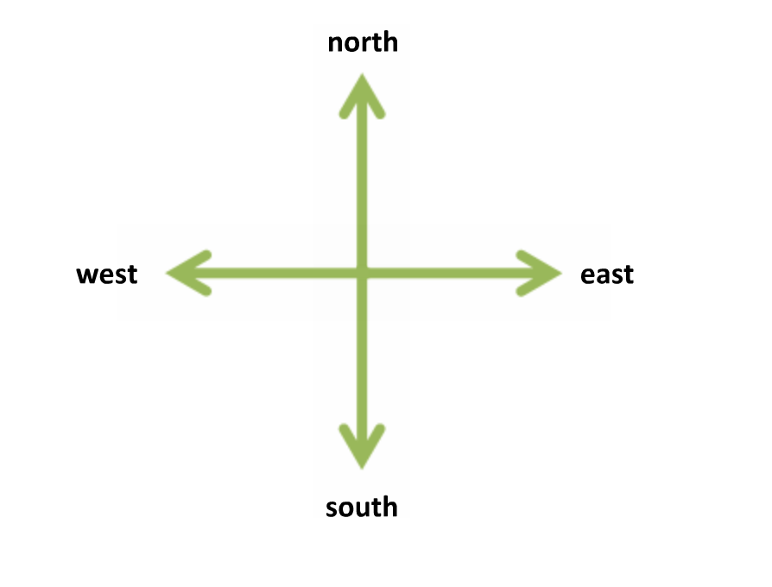
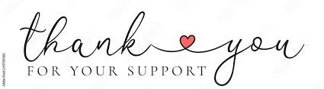
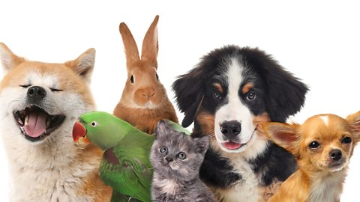
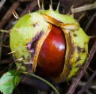
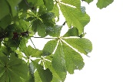
Spelling [Y2] –We will be continuing to spell words ending in – le e.g. prickle, uncle, candle, shovel.
RE – We will be understanding that Hindus believe there is one God worshipped in many different forms.
Geography – We will be identifying the four compass directions.
Art – Exploring Thread – We will be exploring plaiting, threading and using knotting techniques.

Gluing & Running Stitch
fixing materials.

PRSHE – Keeping myself safe

PE – Gymnastics
Music – We will be creating sound patterns based on call and response.

Phonics [Y1] – We will be recapping and consolidating the phonemes: i-e [time],
o-e [stone], u-e [oo - flute] and u-e [y/oo - cube]. Our tricky words are again, thought, through.

English – We will be continuing our non-chronological report about ducks. We will make notes and write facts about what they eat and their life cycle.
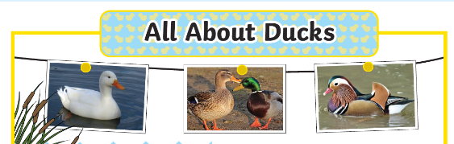

Science – We will be recognising animals that make suitable pets.
Maths –
Year 1 – Shape – We will be sorting shapes. Counting and Money - We will be counting objects in twos, fives and tens. We will be recognising all coins and notes.

Year 2 – Time – We will be telling the time for o’clock, half past, quarter past and to. We will also be telling the time to 15 minutes.

Horse Chestnut Class
wb 2nd February, 2026

